**EXP#6 Grading Reference**

**Experiment Admin:**  **Date:**

|  |  |  |  |  |
| --- | --- | --- | --- | --- |
| **Student ID No** | **Name and Surname** | **Points (for Admin)** | | |
| **QZ** | **Expr** | **Total** |
|  |  |  |  |  |

In this experiment, you are going to study **sinusoidal steady-state** response of RLC-circuits. After initial transients, the steady-state response is what one can get as a useful work from a system. The method is widely practiced in Power and RF Engineering. For that matter, you are going to see the steady-state pictures of RC, RL and RLC circuits. You need to construct **voltage** and **current phasors** to practice the method.

You need to study experiment document first, to get familiar with the subject. You can find all required information in the Lab Manual [1] and referances therein. Be prepared to run simulation on LTspice™ .

**Oscillator settings**

* Waveform: **Sinusoidal Wave**
* Amplitude: **7.1 V**
* Frequency: **1 kHz**
* Phase = **0 degree as a reference**

**(A1) Transient Analysis of RC Circuit**

**Circuit: Fig 6.1 ,** R = **1 kΩ**, C = **100 nF**

Run transient analysis of the following circuit to measure the all **voltages** and **currents**

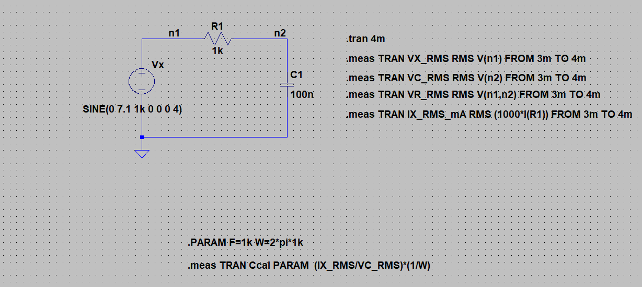

**Report Requirements**

* Fill out **Table A.1** and **Table A.2**
* Include **VX(t)** and **VC(t)** waveforms together
* Include **VX(t)** and **VR(t)** waveforms together

|  |  |  |  |  |  |
| --- | --- | --- | --- | --- | --- |
| **Table A.1** | | | | | |
| **Voltages [V(rms)]** | **Phase** | **Voltage Phasor** | **Currents [mA (rms)]** | **Phase** | **Current Phasor** |
| **Vx =** | **θVX = 0°** | **∠0** | **Ix =** | **θIX = °** | **mA ∠** |
| **VR =** | **θVR = °** | **∠** | **IR = IC = Ix = mA** | | |
| **VC =** | **θVC = °** | **∠** | **θIR = θIC = θIX = °** | | |
|  |  |  |  | | |

|  |  |
| --- | --- |
| **Table A.2** | |
| Voltage phasors in polar coordinate system  Im  Real  **VC**  **VR**  **VX** | **(A2)** Write down the relation between effective amplitude of phasors: |VX |, |VC |, |VR | =? |
| **(A3)**Calculate value of the Capacitor:  C = **(Ix(eff)/Vc(eff))*(1/w) =** |
| **(A4)** Write down capacitor voltage in time domain:  VC(t)= ? *sin(2*π*f*t + ?°) |

VX , VC

VX , VR

**(B1) Transient Analysis of RL Circuit**

**Circuit: Fig 6.2,** R = **3.3 kΩ**, L = **330 mH**

**Oscillator settings: as in Section-A**

Run transient analysis of the following circuit to measure the all **voltages** and **currents**

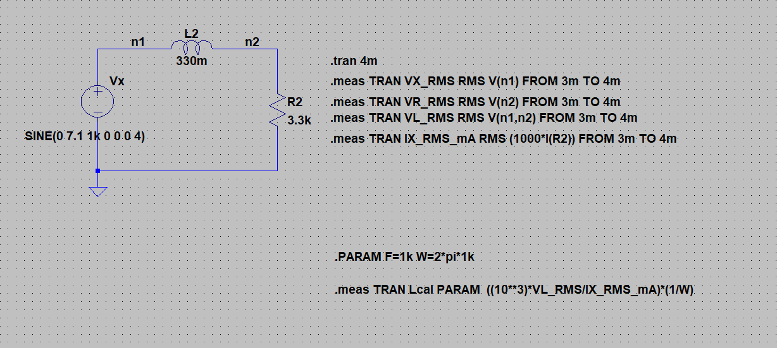

**Report Requirements**

* Fill out **Table B.1** and **Table B.2**
* Include **VX(t)** and **VR(t)** waveforms together
* Include **VX(t)** and **VL(t)** waveforms together

|  |  |  |  |  |  |
| --- | --- | --- | --- | --- | --- |
| **Table B.1** | | | | | |
| **Voltages [V(rms)]** | **Phase** | **Voltage Phasor** | **Currents [A (rms)]** | **Phase** | **Current Phasor** |
| **Vx =** | **θVX = 0°** | **∠ 0°** | **Ix =** | **θIX = °** | **∠ °** |
| **VR =** | **θVR = °** | **∠ °** | **IR = IL = Ix = mA** | | |
| **VL =** | **θVL = °** | **∠ °** | **θIR = θIL = θIX = °** | | |

|  |  |
| --- | --- |
| **Table B.2** | |
| Voltage phasors in polar coordinate system  **VX**  Im  Real  **VL**  **VR** | **(B2)** Write down the relation between amplitude of phasors: |VX |, |VL |, |VR | =? |
| **(B3)**Calculate the value of inductor:  L =VL(eff)/IL(eff)*(1/w)= |
| **(B4)** Write down inductance current in time domain:  iL(t)= ? sin(2π*f* t + ?) |

VX, VR

VX, VL

**(C1) Transient Analysis of RLC Circuit**

**Circuit: Fig 6.3,** R = **1.0 kΩ,** L = **100 mH**, C = **100 nF**

**Oscillator settings: as in Section-A** with **fo = 1.6 kHz**

Run transient analysis of the following circuit to get the **voltage** waveforms

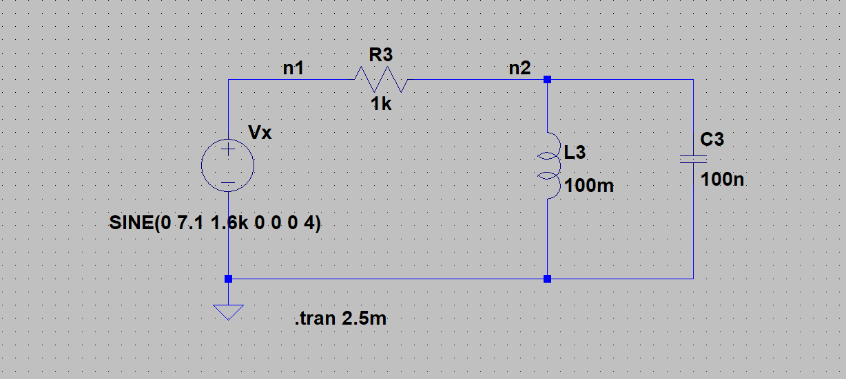

**Report Requirements**

* Include **VX(t)** and **VC(t)** waveforms together

**(C2) Frequency Analysis of RLC Circuit**

Run AC simulation for the following circuit to get the voltage of **VC(f)** on semi-logarithmic scale

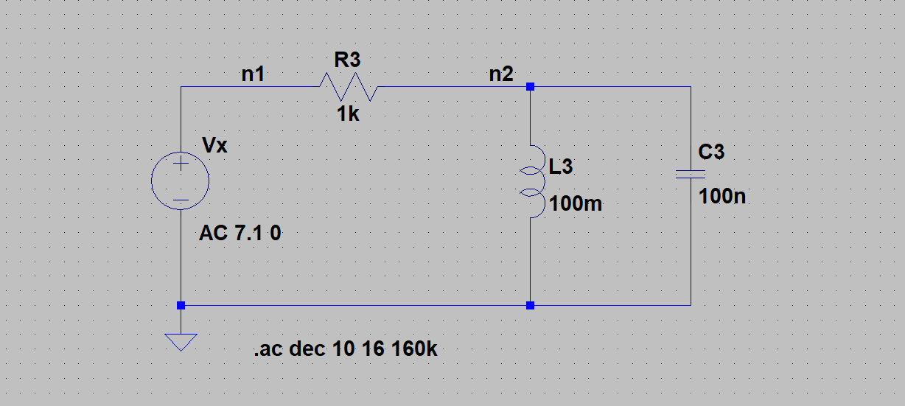

**Report Requirements**

* Include **VC(f)** graph
* Measure the oscillator frequency that provides maximum voltage:  **VC(RMS)**= **fm** =
* Calculate resonance frequency of the circuit

fo = =

VX, VC

IR(t)

VC(f)

**References**

[1] Basics of Electrical Circuits Lab Manual, ITU, online, 2013.

Please report any error to [ozayan@itu.edu.tr](mailto:ozayan@itu.edu.tr) [R2021.1, Ayan Derya]